Retail Sales Dashboard

About: This dashboard shows about how many orders have been placed by customers and in how many states these orders are being placed. It also tells, about which state have highest and lowest order. This dashboard consists of multiple KPI's like Current year month to date of order amount, year to date of order amount, previous year of order amount and so on with some filters. Along with that I have also used different charts for showing trends and summary report, Trend chart (Line chart), Map chart, Pie Chart and the table of Top 5 transactions of states.

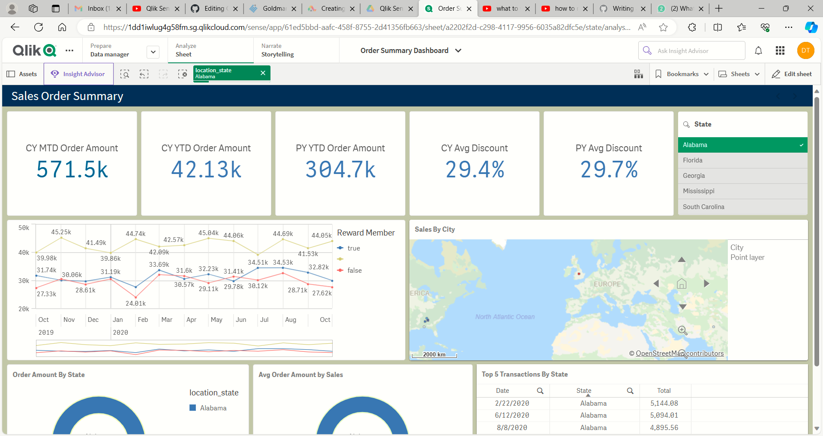

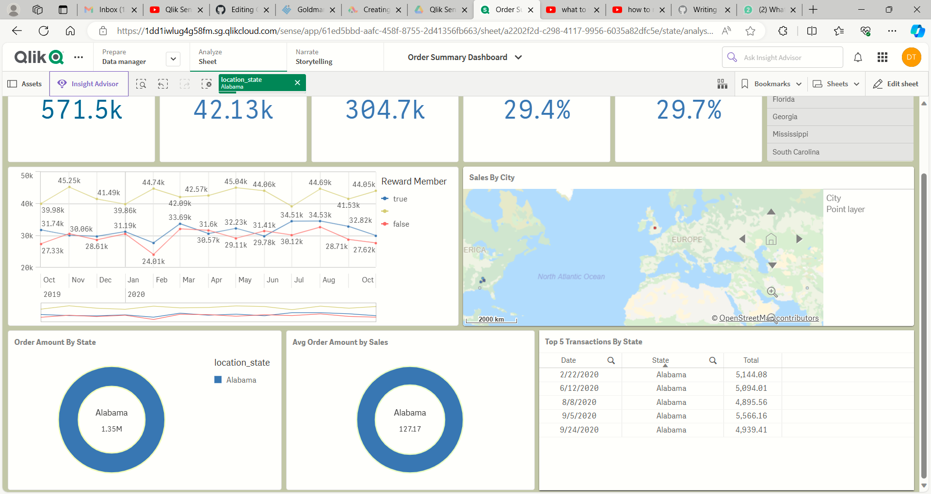

Data Dump:

